Environmental Justice Audit
Data from NAM’s Social Action Committee, Northside’s (NS) Social Justice Committee and Individual Interviews

This report was generated by review of the Social Action Minutes from the last year, interviews with two individuals: Rose Maxwell, representing the Social Committee, and Jim Barber, vestry member with knowledge in environmental issues, notes from Kristin Klevering, member of NS’s Social Justice Committee, and written by Fran Board, member of the Social Action Committee.

AREA I. EDUCATION

1. Is social justice an existing area of concern and activity within your house of worship? If yes, are there social justice education efforts or activities that can be used as a foundation for your EJ activities?

Respondents affirmed that social justice has always been a definite concern and activity within St. Aidan’s and NS Presbyterian. These activities can clearly be used as a foundation for efforts in environmental justice.

Examples of activities involving members of both St. Aidan’s and NS include:

A. Historically, members have always been involved in peace and justice movements.

B. The Rotating Men’s Shelter: we provide warm sleeping arrangements for homeless persons from the city shelter, including transportation, space, socialization with members, food, access to computers, reading materials, and small gifts of warm clothing etc. This year’s shelter arrangements for St. Aidan’s will occur during the week of November 14-21.

The program by the city is in some jeopardy now due to funding cuts. The following recent message by city staff Ron Gregg has alerted our congregation to action such as fund raising. With an increased number of volunteers for functions formerly done by shelter staff, St. Aidan’s/Northside’s week will still go on this year.

“Subject: SAVE THE ROTATING SHELTER PROGRAM

“Ann Arbor area congregations have the opportunity to make sure the Rotating Shelter Program survives the cutbacks in local government funding. The congregations are taking the lead in providing coordinators for the program and transportation of the bedding from one congregational host site to another. We are asking for financial support for the lead coordinators and for truck rental. Many congregations have already stepped up.

Here is a FUN event for individuals to contribute to the cause. It is a free benefit rock performance at the Creekside Grill on October 23. Come listen to the music and order some good food. Part of the proceeds will go to support the shelter program.”

C. Yearly participation in the Crop Hunger walk
This year's CROP Hunger Walk took place Sunday 10/2/11. Registration was at Bethlehem United Church of Christ (423 South Fourth Ave., Ann Arbor) and started at 1:00 p.m. The walk started at 2:00 with a choice of either a one-mile or five mile route. Several members participated. This year’s event is benefiting 15 local hunger organizations.

D. Outreach Fairs showcasing local social service organizations

Historically we have brought social service agencies traditionally supported by our two churches in for receptions following Sunday services. Connections to these agencies are changing now, from the receptions to personal contact outside of Sunday and notices on our shared bulletin board, sometimes accompanied by fund raising. Job openings are also shared on the board.

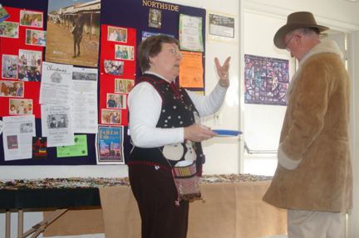

E. Monthly participation in serving meals to local city shelter (Delonis) guests. Members cook and serve.

F. Christmas gifts to children and families in local social service organizations. We have connected with more than one organization, usually collecting gifts by placing a Christmas tree in the lounge with suggested gifts hanging from the branches. Often there are specific requests for large items such as bicycles.

G. Annual Bread for the World Offering of Letters
Parish members of both churches write letters in coordination with the Bread for the World Program. Educational programs are given by members during the campaign and throughout the year.

H. Film showings of topics of social justice, e.g., “Through My Eyes: a documentary where young people of faith talk about their struggle with coming to terms with their sexual orientation and how that shaped their faith story.”

I. Christian Education programs on topics of social concern, e.g., homelessness. There is consideration for more topics in the future such as anti-bullying.

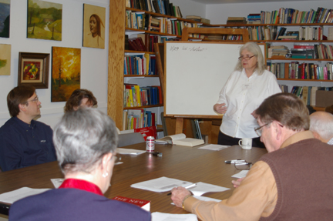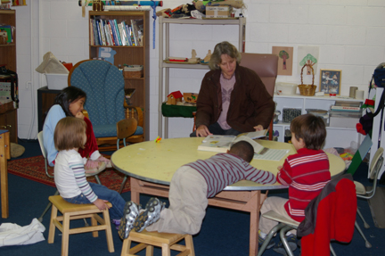

J. Consideration and planning for the future in terms of advocacy with legislators and key community leaders about issues of systemic justice.

K. Members of an organization of homeless are selling their own newspaper after church once a month on Sundays, beginning March 13th.

L. Mission Trip to New Orleans following Hurricane Katrina

In 2008, a group of 15 people from St. Aidan’s and Northside Presbyterian (with 2 other people) traveled to New Orleans to help with clean-up and restoration in the wake of Hurricane Katrina. All fall the children at Northside/St. Aidan’s had worked to restore a beautiful, hand built, doll house to be given to a brand new Episcopal mission in the 9th ward of New Orleans. The 9th ward, the poorest neighborhood on New Orleans, was directly impacted by the negligence on levy maintenance. One levy break annihilated a large portion of the 9th ward and left the infrastructure of the whole ward inexistent. The new church grew out of the mission of the Diocese of Louisiana to the dispossessed of the ward. Two of our members drove a truck to New Orleans with the dollhouse, a donated organ, and other donations. During our mission trip our delegation worked clearing debris and vegetation in the 9th ward, right in the shadow of the place where the levy broke, and in a neighborhood where the devastation was so complete that the remaining structures were not salvageable. We also worked in other poor neighborhoods (Gentilly and Filemore) in preparation for rebuilding and restoration of some housing.
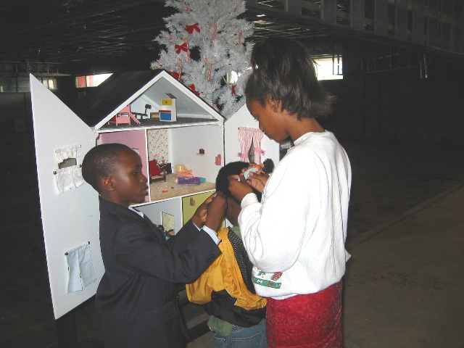
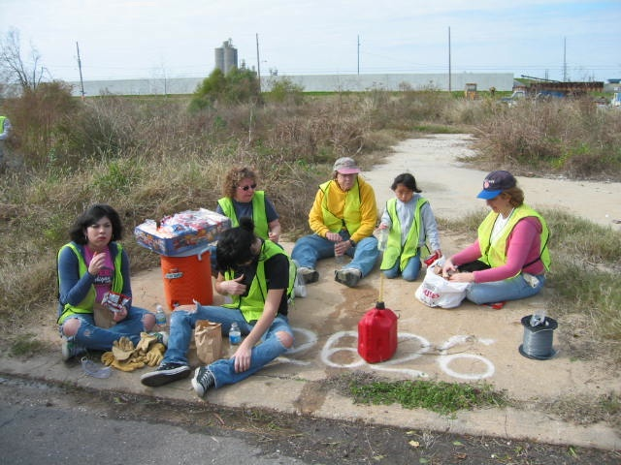
2. How comfortable and aware of environmental justice issues is your green team?

The majority of green team members are aware of environmental issues in varying degrees. For people outside of the green team, even in some individuals of high interest in social service, the concept of environmental justice (E.J.) is a new way of looking at justice. The definition provided in the questions was very helpful.

3. Has our house of worship

a. Ever conducted an education program of any kind focused specifically on E.J. (as defined above)?

We have had an educational program on energy consumption and the carbon footprint, although we did not conceptualize it specifically as environmental justice. We had an excellent lecture by a university professor on the type of plants and trees in our woods. Again, though not conceptualized specifically as justice, the focus on native plants, and protection of vulnerable species and soil was informative and well attended.

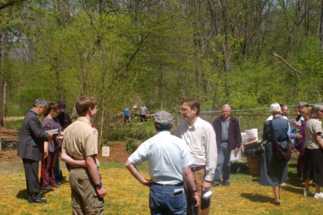

b. Studied or educated about EJ concerns? Particularly in our community?

Not specifically. We are excited about doing this now.

c. Visited environmentally degraded sites in our region that are located in low-income communities or communities of color, to see E.J. concerns firsthand?

Not officially. Jim Barber has visited these sites, and others likely have.

d. Held a screening of an EJ film such as Erin Brokovich “In the Light of Reverence” or others?

No

4. Are there individuals or organizations in your area that you can contact to learn about EJ issues?

Absolutely. Ann Arbor, Michigan, has many individuals and organizations with present or potential interest in E.J. As stated above, NS’s Social Justice Committee is actively investigating contact with outside agencies. A prime one close at hand is the Interfaith Council on Peace and Justice (ICPJ). They rent space in our building.

Top Priorities

This group did not feel ready to identify the top two or three ideas or priorities for action. I think the overall impression is a need to educate church members about the concept of environmental justice and where it fits within social justice, a concept with which the committees are already committed.

AREA 2: RELATIONSHIPS WITH ENVIRONMENTAL LEADERS

1. Has your house of worship identified EJ leaders in our region?

Not from the Social Justice members.

If not, what are some organizations in our region that work on EJ issues?

The US Environmental Protection Agency, 2565 Plymouth Road #1, Ann Arbor,
The Great Lakes Commission (2805 S. Industrial Hwy # 100) Ann Arbor
The Ecology Center 117 N. Division St., Ann Arbor, 48104-1
Michigan Department of Natural Resources and Environment Constitution Hall 525 West Allegan Street P.O. Box 30473 Lansing, 48909-7973
Saline River Greenway Alliance (SRGA) (Saline-Milan Patch, January 25, 2011)
Legacy Land Conservancy of Ann Arbor
River Raisin Watershed Council
Washtenaw Co. Parks and Recreation Dept. 2230 Platt Rd. Ann Arbor
Huron River Watershed Council
Huron-Clinton Metroparks

2. Has our religious community ever conducted a meeting, either by phone, over the Internet, or in person, with an EJ advocate or activist in our region?

Not known.

AREA 3: ADVOCACY

1. Has our house of worship ever conducted advocacy focused on environmental justice, such as letter-writing campaigns, meeting with public officials, or working with advocates to educate the EJ community about the effects of pollution?

Our annual letter-writing campaign for Bread for the World clearly attacks an EJ issue in that we press for congressional action on issues of agricultural subsidies, funding for low-income areas, etc.

2. Are there EJ issues that you believe are of significance in your region?

Many. The following are only a sample. We had a problem with water system delivery on our church property. The city asked us for input as to the solution and finally made their own decision to solve the problem. We presently have a potential problem with a crumbling foundation, which could impact the building safety. Members created a settling pond at the bottom of our land that cleans our drainage water before it goes into the storm sewer that leads to the Huron River.

Jim Barber, knowledgeable about local pollution sites identified the following.

a. A report that the smoke from the Ford Rouge river plant blew cleaner if it blew toward Dearborn than toward Detroit. The implication was that the furnaces worked harder if the wind was blowing toward Detroit and slower if blowing toward Dearborn.
b. There was once a single furnace steel mill between Plymouth and Broadway. The implications of this in terms of effect on the land need to be studied
c. Being an industrial area, Detroit in the past sacrificed homes of urban relatively low-income families to build plants. People were not compensated fairly for their long-time homes.
d. The area along the Huron River entering Main Street in Ann Arbor from the east is said to be to be very polluted and hampering clean development. A big problem everywhere is that the cost of clean up is so massive. The biggest aim is to prevent the pollution before it occurs.
e. Uncontaminated fish are rapidly becoming less available in the Great Lakes and in Michigan rivers and streams.
f. We need to watch the brew (plume) coming out of the old city dump. There is an old dump at Platt and Packard, Platt and Ellsworth. Now we dump in Wayne County along I 14.
g. There is a big problem with rats in older houses in Detroit.
h. Sand washing into lakes, changing the shorelines,
i. Automobiles dripping oil into the pavement, draining into storm sewers.

The Social Action, the Green Team, and others have plenty of opportunities to advocate around these issues after priorities are set.

3. Has your house of worship participated in an internationally focused environmental justice activity or initiative?

Not to our knowledge.

4. Are there any barriers to promoting EJ advocacy within your institution?

There is a low-moderate level of knowledge about EJ. Our members often have the political courage to confer and confront civic leaders when we have enough knowledge about problems and potential advocacy. The Social Action Team at NS is already talking about more outreach with community leaders.

Strategies for making EJ advocacy more accepted and effective:

There seemed to be a general consensus that we need to start with educational efforts to help in conceptualizing environmental justice within the broader concept of social justice. This joint assembly of Episcopalians and Presbyterians has a long history of belief in and advocacy for social justice.

Appreciation is extended to Rose Maxwell, representing the Social Action Committee of NAM, Jim Barber, vestry member of St. Aidan’s, and Kristin Klevering from the NS Social Justice Team for their contributions.

Fran Board 3/10/2011, amended 10/19/11

